Each page below is a banner that scrolls up and down similar to: <http://www.wellworkforce.com/about-us/>

Videos and pics of trainings not yet provided.

LOGO

**Let’s Talk**

**Workforce Performance Trainings**

SERVICES ABOUT RESOURCES CONTACT LOGIN

**WORKFORCE STRONG**

**HUMAN MOVEMENT *Redefined***

SERVICES ABOUT RESOURCES CONTACT LOGIN

LOGO

**PREVENTION SERVICES pushing the boundaries of innovation**

**More than *health and safety* trainings**

**More than *ergonomics***

**Experience practical, effective, and sustainable**

**lifestyle and workforce movement habits**

**LEARN MORE**

A group of people posing for the camera

Description generated with very high confidence

logo SERVICES ABOUT RESOURCES CONTACT LOGIN

logo SERVICES ABOUT RESOURCES CONTACT LOGIN

**SCROLL BANNER OF CLIENTS’ LOGOS**

LOGO SERVICES ABOUT RESOURCES CONTACT LOGIN

**Access Knowledge and Industry Expertise**

**A close up of a sign

Description generated with very high confidence (these get spread out across page)**

**info@wfstrong.com**

Banner scroll left and right

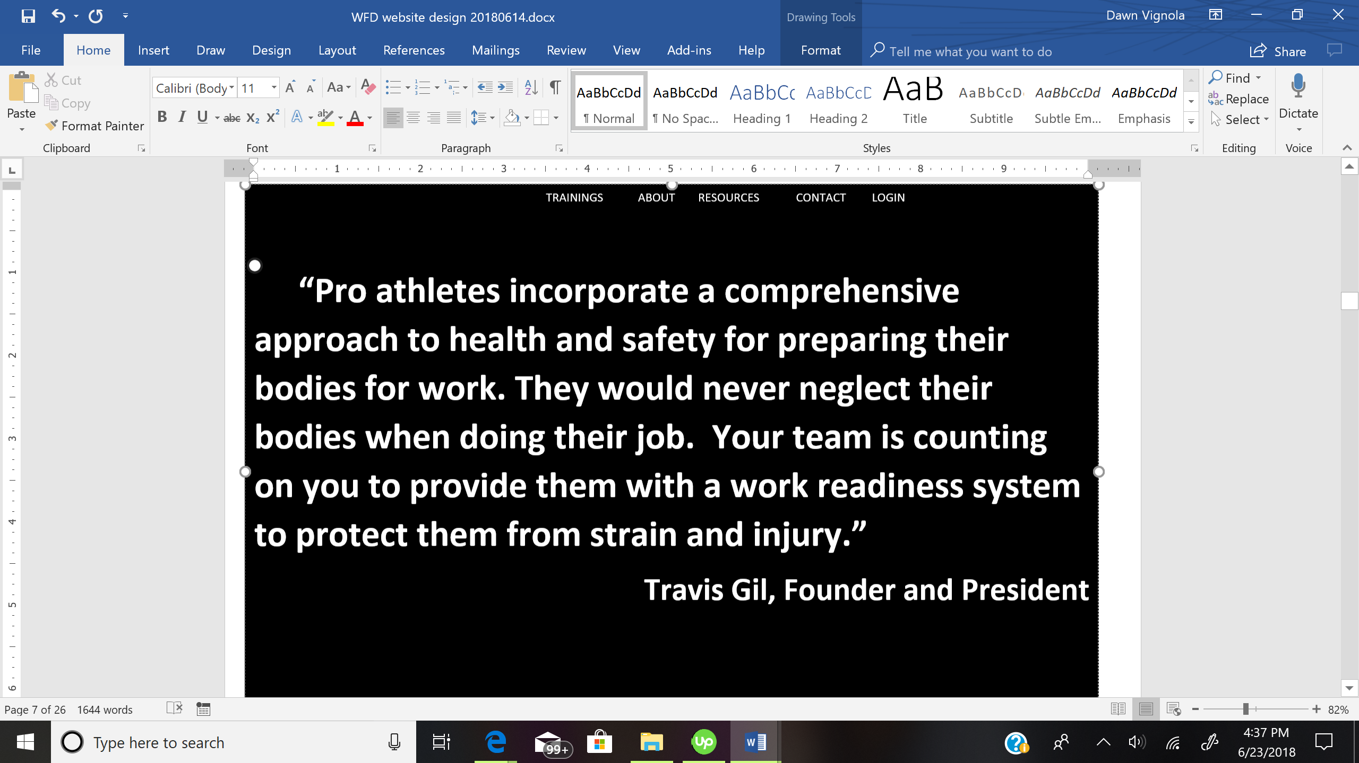 SERVICES ABOUT RESOURCES CONTACT LOGIN

Training pic

Training video clip or pic

Programs custom designed to combat the trends of rising healthcare costs, and the costs of lost productivity due to human movement issues.

**GET INSIGHTS AND WORKFORCE MOVEMENT, HEALTH, AND SAFETY TIPS STRAIGHT TO YOUR INBOX**

**SUBSCRIBE**

**ABOUT PAGE**

logo SERVICES ABOUT RESOURCES CONTACT LOGIN

**WHAT WE DO**

*We have your solution”*

|  |  |
| --- | --- |
| WORKFORCE SAFETY AND PREVENTION  Personal Protective Equipment (PPE)  OSHA  Customized Injury Prevention | A close up of a logo  Description generated with very high confidenceWORKFORCE PERFORMANCE  Joint Flexibility, Posture Correction, Ergonomics  Repetitive Task Avoidance, Muscle Elasticity  Muscular Coordination, Balance, and Range of Motion |
| WORKFORCE MOVEMENT    Lifestyle and Workstyle Assessment  Comprehensive Nutrition Guidance | A picture containing text  Description generated with very high confidenceWORKFORCE READINESS  Functional Movement Screening  Tracking, Coaching, Support, and Resources |

click through on each of the pictures below to training pages

SERVICES ABOUT RESOURCES CONTACT LOGIN

logo

LOGO

SERVICES ABOUT RESOURCES CONTACT LOGIN

Your Training Team

Over two decades of injury prevention training experience

Prevention Services

Human Performance Trainers

Safety Trainers

Functional Movement Experts

Scientifically Proven Results

Programs for corporate and government organizations

Human Movement Specialists

*Proven track record of increasing employee’s potential contributions by preventing injuries, increasing engagement, and creating unity among workers.*

*Improve efficiency, increase productivity, ensure safety, and promote health.*

logo

SERVICES ABOUT RESOURCES CONTACT LOGIN

BELOW-SCROLLING LEFT TO RIGHT BANNER (WIDER THAN DEPICTED BELOW)

By the Numbers Core Areas of Expertise The Results Speak for Themselves

|  |  |  |  |  |
| --- | --- | --- | --- | --- |
| * Non-fatal Workplace Injuries Cost Employers $62B | * Functional Movement Systems (FMS) |  | * Greater Employee Retention | * Less time Being Sick |
| * $1 spent on injury prevention programs saves $3.37 | * Specialized Group Human Movement Sessions | A picture containing text  Description generated with very high confidence | * Decreased Costs from Healthcare Claims | * Greater Job Satisfaction |
| * A single worker’s compensation claim, $130,000 | * Safety Training |  | * Increased Worker Productivity * Decreased Risk and Number of On-Site Injuries * Decreased Worker’s Compensation costs * Weight Loss | * Higher Company Morale * Increase Quality of Life * Increase Motivation Levels * Better Partner Outside of Work * Decrease Stress Levels |
| * Rising healthcare costs | * Registered Dietitians, Nutritional Evaluations |  |
| * Lost productivity due to health-related issues | * Ongoing Evaluations and Coaching |  |

**Thinner banners**

SERVICES ABOUT RESOURCES CONTACT LOGIN

**Injuries can happen anywhere and that’s why we put such an emphasis on prevention and performance.**

FOR NOW: VIDEO – WFSStrong-HD-3.mp4. The video will be centered in a banner here with Worforce Strong logo on the left. I would need to see it in draft for a better idea of whether it would be good to have additional items on the banner.

RECOMMENDATION – NEW VIDEO USING CHARACTER DRAWING IN WHICH SEE WRITTEN FORM OF SCRIPT DRAWN OUT AND VOICE OVER OF DIALOGUE.

SEE <https://www.youtube.com/watch?v=FJqa4WinIcY> for example. That was for a national conference shown at a workshop. In your case, instead of using a person standing there, you would have drawings of examples for everything from someone sitting uncomfortably to what a training would look like (an instructor helping someone learn how to do a certain functional movement) while a voice over provides the details of what you do and costs of not doing it.

LOGO SERVICES ABOUT RESOURCES CONTACT LOGIN

***“I have more energy and I am moving a lot better. My flexibility has definitely improved. I’m also sleeping more soundly, breathing easier, and have a clear mind. I hope you keep this program going, not just for our group but for all employees.”***

***Name of person***

****“See an example” links to video of injury prevention training – you can do either of the stretching videos. You may need to create something. Most of your videos look fitness related since they take place in a gym. A good video for this service line would be one showing injury prevention training in a work setting, even if that’s not where you do it necessarily.**

LOGO SERVICES ABOUT RESOURCES CONTACT LOGIN

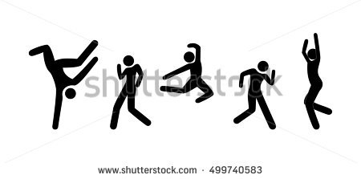

**TRAINING – GOVERNMENT PAGE**

LOGO SERVICES ABOUT RESOURCES CONTACT LOGIN

**FEDERAL, STATE, LOCAL GOVERNMENT**

**INJURY PREVENTION SERVICES**

We make it a great day for you and your team.

**banner see as scroll down from top government page**

LOGO SERVICES ABOUT RESOURCES CONTACT LOGIN

**WFS specializes in the training needs for the six (6) different employee categories or groups identified by OSHA Federal Employee Occupational Safety and Health (FEOSH) standard at 29 CFR Part 1960.**

* **Management officials, 1960.54,**
* **Supervisory employees, 1960.55**
* **Safety and health specialists, 1960.56**
* **Safety and health inspectors, 1960.57**
* **Collateral duty employees & safety and health committee members, 1960.58**
* **Employees & employee representatives, 1960.59**

Engaged

Productive

Healthy

Motivated

LOGO SERVICES ABOUT RESOURCES CONTACT LOGIN **CELLS GOING ACROSS– EACH WITH AN IMAGE OF YOUR TEAM PROVIDING INJURY PREVENTION TRAINING – IF YOU HAVE THEMJ.** TEXT IN BOX WOULD BE OVER THE IMAGE, SO EACH IMAGE SHOULD REPRESENT THAT DESCRIPTIVE WORD

***Starting a workplace safety and loss prevention program lowers the cost of doing business.***

**Lower Workers’ Compensation Costs Enhance Employee Morale and Productivity   
Reduce Accidents Improve Workers Safety**

"In the past 15 years,   
 we've provided nearly $12 billion in compensation to hundreds of thousands of people” [working for the Department of Energy]. *U.S. Department of Labor, Office of Worker’s Compensation Programs (OWCP) Director Leonard Howie.*

In an era of budget constraints, health and safety tends to be one of those areas where money does not go. That limits training in health and safety and the ability to identify risks and prevent injuries. *Milly Rodriguez, the occupational health and safety specialist for* [*American Federation of Government Employees*](http://www.baltimoresun.com/topic/jobs-workplace/unions/american-federation-of-government-employees-ORCIG000117-topic.html)

LOGO SERVICES ABOUT RESOURCES CONTACT LOGIN

LOGO SERVICES ABOUT RESOURCES CONTACT LOGIN

**CORPORATE**

**HUMAN MOVEMENT SPECIALISTS**

Changing the way the world does business.

**SCROLLING UP BANNERS –LOGO HEADER STAYS THE SAME**

A screenshot of a cell phone

Description generated with high confidence**A close up of text on a black background

Description generated with very high confidence**

**MAXIMIZE EMPLOYEE ENGAGEMENT**

***For every $1 spent on an injury prevention program, $3.37 is saved***

**REDUCE LOST TIME CLAIMS**

**AVERAGE OF LT CLAIM IS $125,000**

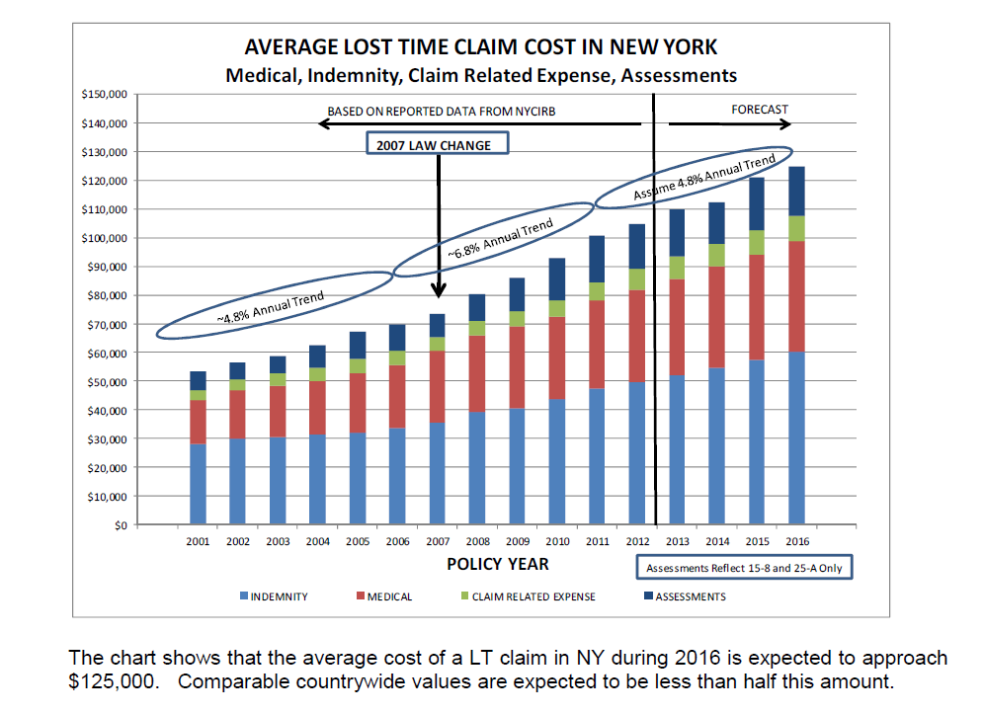

**MINIMIZE MEDICAL COSTS**

**ON AVERAGE, 40% OF BENEFITS GO TO MEDICAL COSTS**

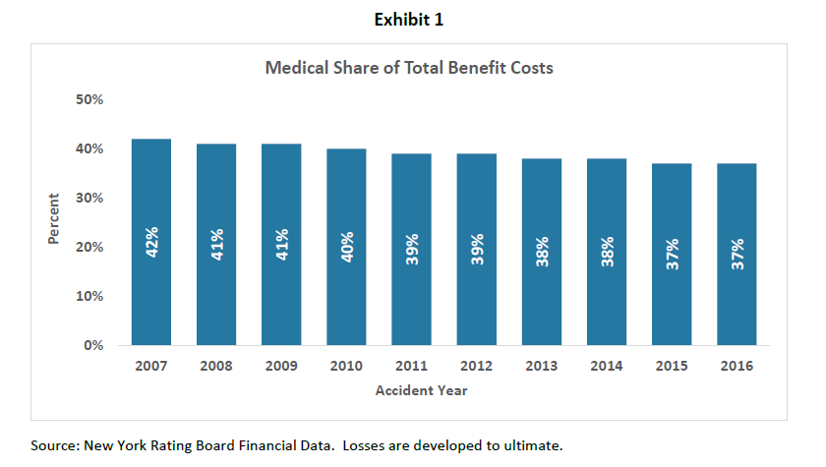

**BOOST YOUR BOTTOM LINE**

**SERVICES DROPDOWN – HYPERLINK FROM EACH TRAINING TO BANNER DESCRIPTIVE PAGE**

SERVICES ABOUT RESOURCES CONTACT LOGIN

**HUMAN MOVEMENT PERFORMANCE AND PREVENTION**

**Work Force Strong’s mission is to provide companies all over the world with a program specifically designed to reduce unnecessary workplace injuries, decrease sick time, implement healthy alternatives, and increase productivity.**

|  |  |  |
| --- | --- | --- |
| **Lifestyle Assessment**   * Job specific analysis * Body composition measurements * Mental and physical limitation assessment | **Functional Movement Screening**   * Uncovers dysfunctional movement patterns * Identifies weaknesses which lead to injuries | **Customized Injury Prevention Training**   * Mobility * Flexibility * Range of motion * Strength * Proper lifting, bending, and twisting techniques |

A drawing of a person

Description generated with high confidence**Banners that move up and over the main landing page and each other**

LOGO TRAININGS ABOUT RESOURCES CONTACT LOGIN

**LIFESTYLE**

**ASSESSMENT**



* Contact stress
* Pace of work
* Psychosocial stress
* Vibration
* Repetition
* Insufficient recovery time
* Forceful movements
* Awkward or fixed postures
* Cold temperatures

**WFS PREVENTITIVE TRAINING  
Eliminate and Reduce Lost Time and Productivity Due to Repetitive Stress Injury (RSI)**

**Who’s at risk?**   
Anyone doing repetitive work like working on keyboards or using tools and instruments doing the same thing over and over.

**What is it?**A form of musculoskeletal disorders, such as tendinitis and carpal tunnel syndrome, that can affect tendons, muscles, nerves, and joints, which can lead to pains, burning, tingling, swelling and loss of joint movement and strength. If not treated, the symptoms can progress into crippling disorders that are difficult to correct.

**How do we help?** *WSF incorporates functional movement techniques into everyday work-life, addressing the effects of:*



**Learn more goes to contact page. Each training prog banner, same width**

**REDUCE WORKFORCE INJURIES AND LOST TIME NOW**

LOGO SERVICES ABOUT RESOURCES CONTACT LOGIN

15 sec VIDEO OF FUNCTIONAL MOVEMENT EXERCISE IN WORKPLACE (NOT FITNESS CENTER)



* *Learn warmup-work readiness*
* *Increase synovial fluid*
* *Achieve greater range of motion*
* *Uncover dysfunctional movement patterns*
* *Identify weaknesses which lead to injuries*
* *Increase blood supply and nutrients to tissue*
* *Decrease joint degeneration*
* *Improve structural imbalances*

LOGO SERVICES ABOUT RESOURCES CONTACT LOGIN

LOGO SERVICES ABOUT RESOURCES CONTACT LOGIN

* *Provide workers with greater elasticity and decreased tightness*
* *Protect workers from strain and injury from all tasks – sitting, lifting, shelving, walking, stairs*
* *Muscular balance, posture from repetitive tasks*
* *Improve structural imbalances*
* *Improve muscle coordination-enhances nerve impulse velocity*
* *Incorporate personal protective equipment (PPE) into daily routine*

**Customized Human Movement Training**

A close up of a logo

Description generated with very high confidence

LOGO SERVICES ABOUT RESOURCES CONTACT LOGIN

Promote health, safety, and team culture

with *proven* injury prevention techniques

**UNDER RESOURCES DROP DOWN**

**(Need blog items), Research, White Papers**

LOGO SERVICES ABOUT RESOURCES CONTACT LOGIN

Blog | **PERFORMANCE AND PREVENTION**

SEARCH

CATEGORIES

Title (blog item or article)  
Posted on …. By ….

Text of blog… tweet FB (#likes)

Blog Item

Blog Item

Search

LATEST ARTICLES

DROP DOWN FOR SELECTING CATEGORIES

Tweets

(Twitter feed) - live

Read More

**WORKFORCE STRONG**

We have been providing injury prevention training for over a decade to government and corporations. Our injury prevention trainings solutions are practical, effective, and sustainable for the entire workforce.

**UNDER LOG IN – to be built out**

**My Trainings**

**CONTACT PAGE**

**As with other items, trying to avoid using video in background to simplify and ensure no problems in viewing anything, especially from government sources.**

COMPANY/GOVERNMENT AGENCY

Workforce Strong  
Address  
New Haven, CT   
(518) 497-5440

TELEPHONE

EMAIL

NAME

LOGO TRAININGS ABOUT RESOURCES CONTACT LOGIN

**CONTACT US**

**A picture containing grass, tree, outdoor, kite

Description generated with very high confidence**